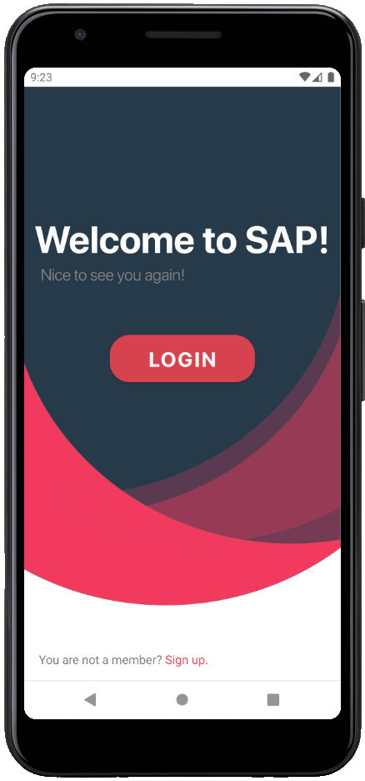

**SAP - SIMPLE ANDROID PROJECT version 1.0**

*July 7, 2020*

*Version 1.0*

# Disclaimer

This handbook is about the application “SAP – Simple Android Project.” It is created for educational purpose only. All and any resemblance to any other “SAP- Simple Android Project” out there is purely coincidental and not intentional.

You are free to use this resource to follow the content of the course and use the application. However, the use of this application for any other purpose or publication without the official consent of Peter Burgs & Starea is prohibited. Please respect and observe the author’s intellectual property rights.

All inquiries regarding this Handbook should be address to the author at [peterburgs.vn@gmail.com](mailto:peterburgs.vn@gmail.com)

© Peter Burgs | All Rights Reserved

# Contents

DISCLAIMER 1

CONTENTS 2

LIST OF FIGURES 1

AUTHENTICATION 2

WELCOME TO SAP 2

SIGN UP AN ACCOUNT 5

LOG INTO AN ACCOUNT 11

FORGOT PASSWORD 12

CREATING 14

CREATE A NEW PROJECT 14

CREATE A NEW SPRINT 17

CREATE A NEW TASK 20

EDITING 22

EDIT PROJECT 22

EDIT PROJECT INFORMATION 22

INVITE NEW MEMBER 22

REMOVE MEMBER 22

REMOVE PROJECT 22

EDIT SPRINT 22

EDIT SPRINT INFORMATION 22

CHANGE DURATION 22

COMPLETE SPRINT 22

START SPRINT 22

REMOVE SPRINT 22

EDIT TASK 22

FILTER TASK BY MEMBER 22

EDIT TASK INFORMATION 22

REMOVE TASK 22

MOVE TO BACKLOG 22

SWITCH: TO DO-IN PROGRESS – DONE 22

ACCOUNT 23

RESET PASSWORD 23

LOG OUT 23

# LIST OF FIGURES

Figure 1 Welcome activity 2

Figure 2 Sign up an account 5

Figure 3 Filled signup form 8

Figure 4 Verification code 8

Figure 5 Enter verification code and confirm 10

Figure 6 Login activity 11

Figure 7 Enter username to receive code 12

Figure 8 Reset password verification code 13

Figure 9 Reset password activity 14

Figure 10 Create new project 15

Figure 11 Open floating action button menu 17

Figure 12 Sprint list activity 18

Figure 13 Create sprint 19

Figure 14 Backlog 20

Figure 15 Create task 21

# AUTHENTICATION

## WELCOME TO SAP

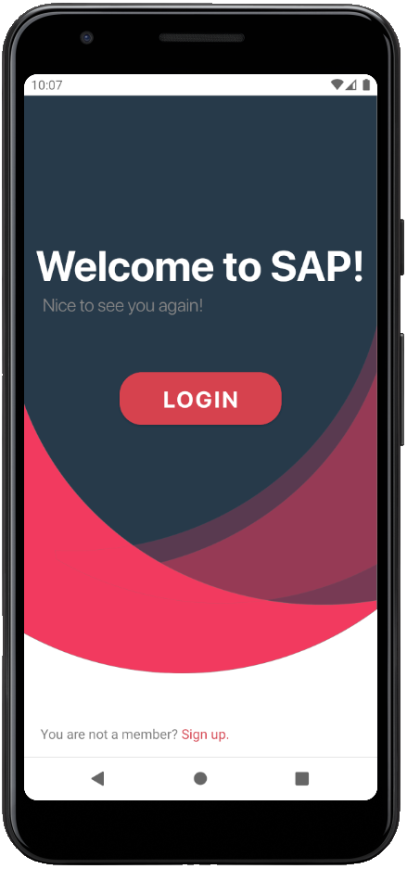

Figure Welcome activity

When you first open the application, the Welcome activity will appear. You have 2 options:

1. Login: If you already had an account.
2. Signup: If you have not had any account.

## SIGN UP AN ACCOUNT

On the Welcome activity, choose “Sign Up”.

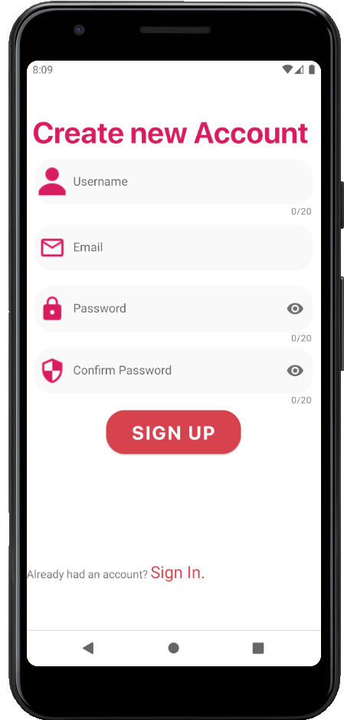

Figure Sign up an account

1. You must fill out all required fields, in which:

* Username: the name you want to display.
* Email: your email, we will send verification code via this email.
* Password: must include lower case, upper case, number & special characters.

Below is an example.

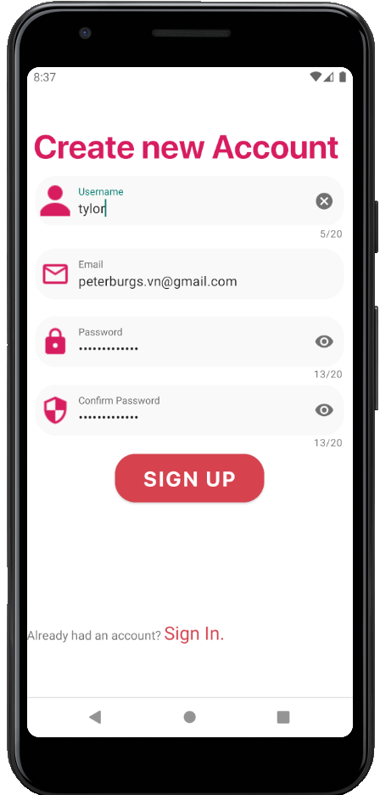

Figure Filled signup form

2. Tap “Sign Up” button to proceed.

3. Open your mailbox, the verification code will be sent immediately.

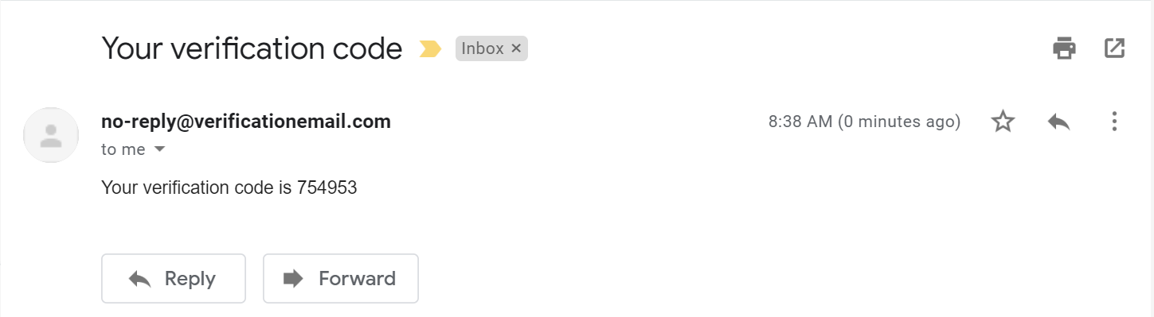

Figure Verification code

4. Fill the code and tap “Confirm” button.

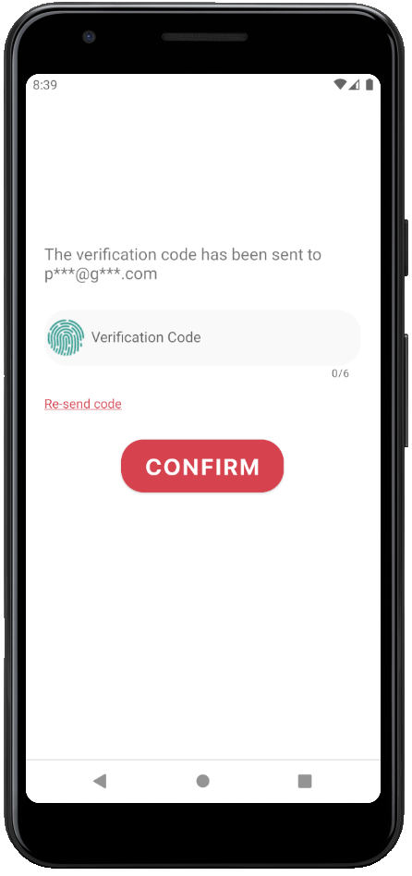

Figure Enter verification code and confirm

5. You will be navigated to the Login activity now.

## LOG INTO AN ACCOUNT

On Login Activity, you must fill out your username and password to continue.

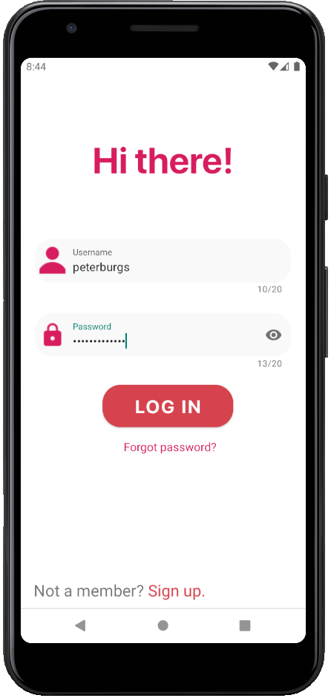

Figure Login activity

*Note: the account used is sample account.

## FORGOT PASSWORD

1. On Login activity, choose “Forgot password”.

2. On new activity, enter your username and tap “Send code. 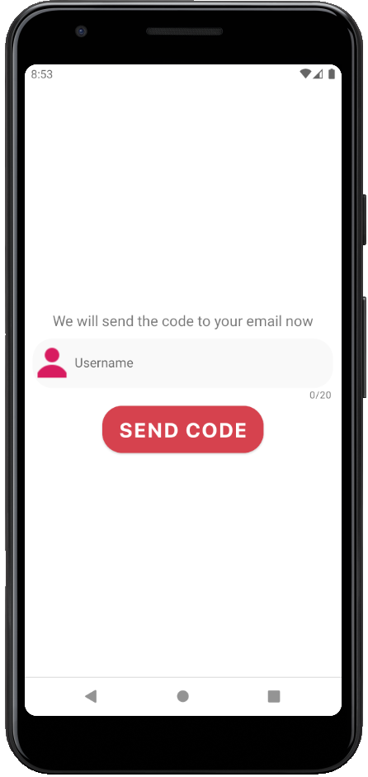

Figure Enter username to receive code

3. Open your mailbox, a verification code will be sent immediately.

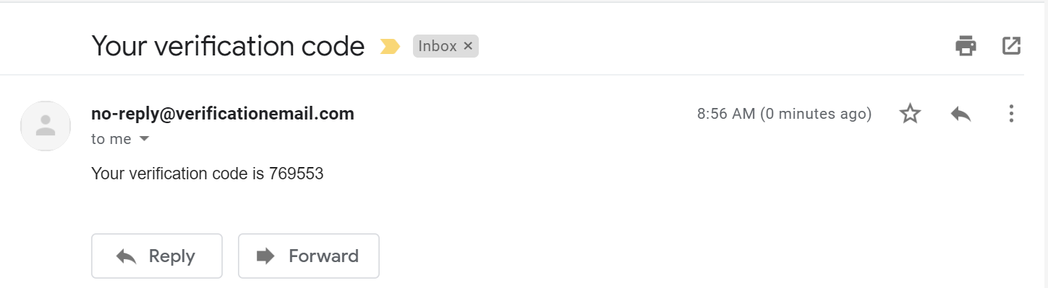

Figure Reset password verification code

4. Fill out required fields, enter verification code, and tap “Confirm.”

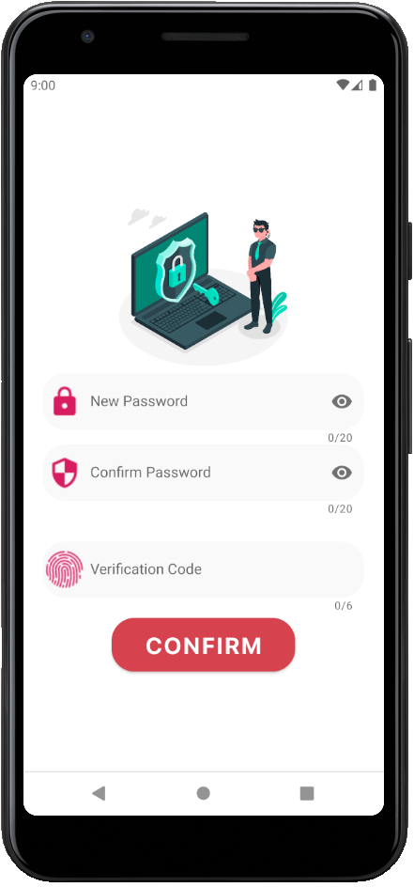

Figure Reset password activity

# CREATING

## CREATE A NEW PROJECT

Once you log in successfully, you will be navigated to the Project list activity which contains all your projects.

1. On Project list activity, tap the icon “+” on toolbar (top of the app).

2. on Create project activity, fill out project name and key, then tap “Create project” button.

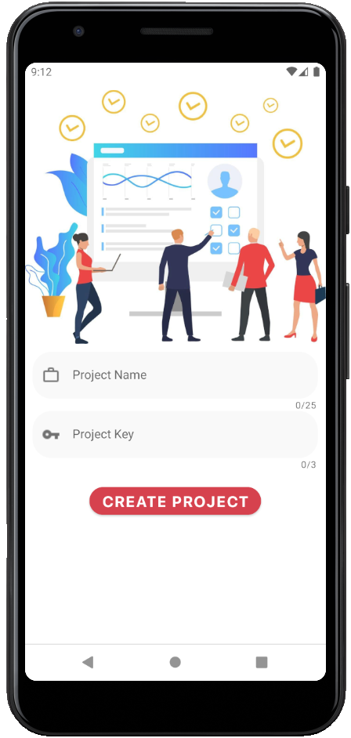

Figure Create new project

3. You will be navigated to the Project list activity. The new project will appear here.

## CREATE A NEW SPRINT

On Project list activity, choose a project.

1. On the project board, tap the floating action button (FAB) on the right-bottom corner.

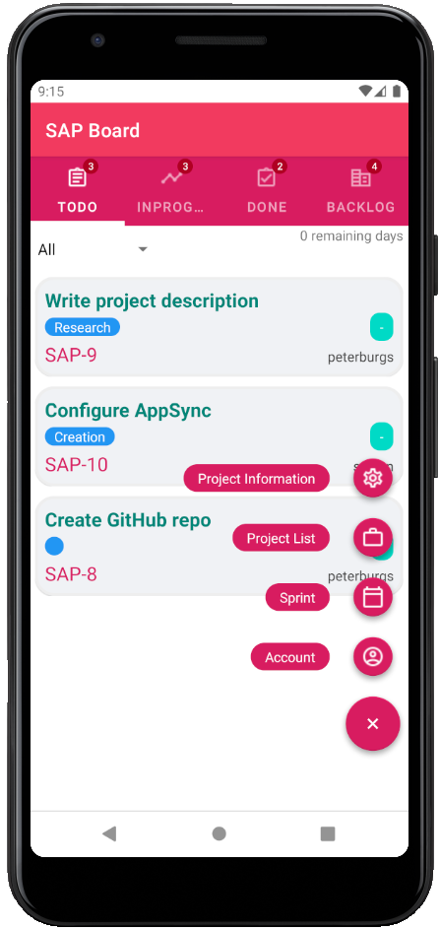

Figure Open floating action button menu

2. Choose “Sprint.”

3. On Sprint list activity, tap the icon “+” on the toolbar (top of the app).

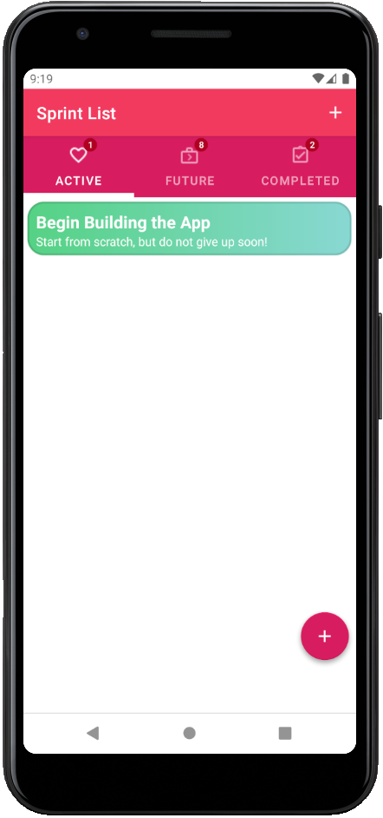

Figure Sprint list activity

4. On Create sprint activity, enter the sprint name (required) and goal (optional).

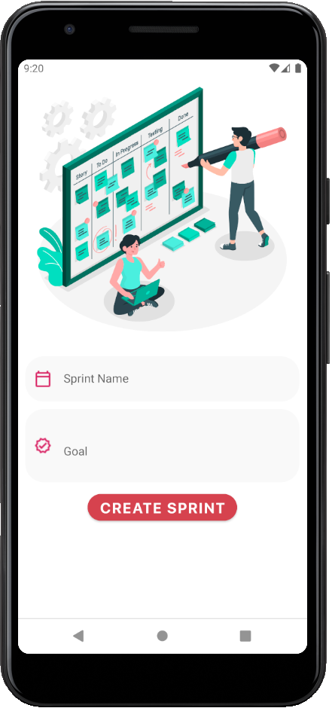

Figure Create sprint

5. Tap “Create sprint” button.

## CREATE A NEW TASK

On Project board activity, choose Backlog.

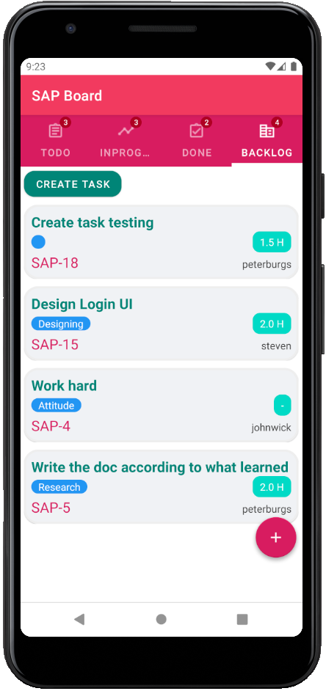

Figure Backlog

1. Tap “Create task” button.

2. Fill out summary, description and estimated time.

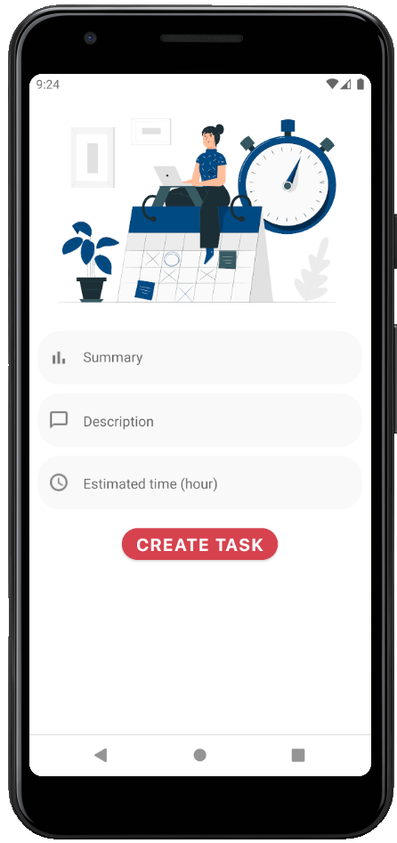

Figure Create task

3. Tap “Create task” button.

4. The new task will be added to Backlog immediately.

# EDITING

## EDIT PROJECT

### EDIT PROJECT INFORMATION

### INVITE NEW MEMBER

### REMOVE MEMBER

### REMOVE PROJECT

## EDIT SPRINT

### EDIT SPRINT INFORMATION

### CHANGE DURATION

### COMPLETE SPRINT

### START SPRINT

### REMOVE SPRINT

## EDIT TASK

### FILTER TASK BY MEMBER

### EDIT TASK INFORMATION

### REMOVE TASK

### MOVE TO BACKLOG

### SWITCH: TO DO-IN PROGRESS – DONE

# Account

## reset password

## Log out